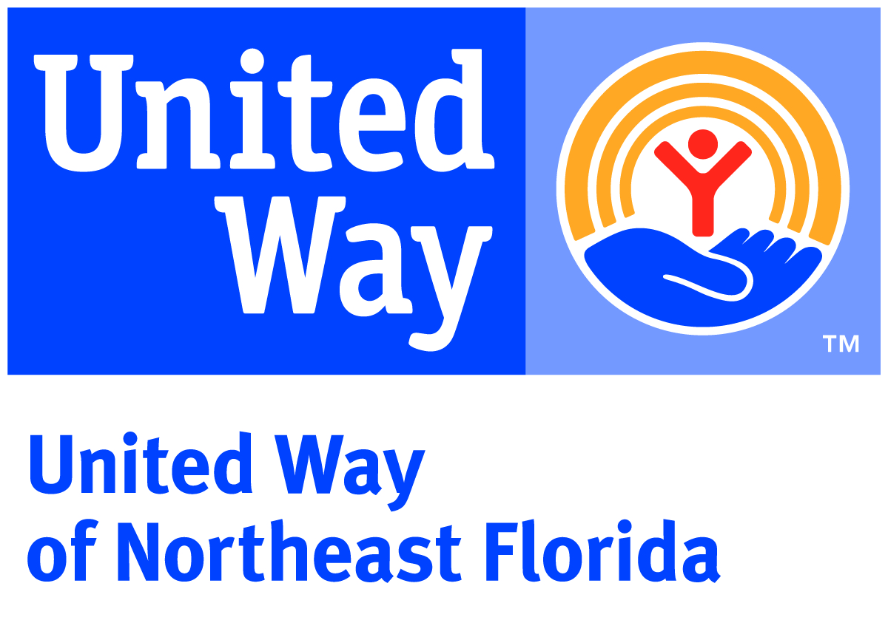

United Way of Northeast Florida
Position Description

Position Title: Administrative Assistant – Corporate Engagement

Department: Resource Development

Reports to: Head of Workplace Campaigns

Reviewed: October, 2017 FLSA Status: Non-Exempt

Vision and Mission:
At United Way of Northeast Florida, we envision a community of opportunity where everyone has hope and can reach their full potential. Our mission is to solve our community’s toughest challenges by connecting people, resources and ideas.

Purpose of Position:
This position manages a select number of process-oriented accounts, assists with database reporting and online campaign setup, manages logistics for campaign programs, and provides advanced administrative support.

Key Responsibilities and Essential Functions:

Operational Support:
- Manage select donor correspondence. This may include assisting with questions related to pledge forms and designations as well as responding to donor and company inquiries and other requests. Convey a professional manner along with a willingness to help.
- Provide support for the Community Builders program (full time temporary team members hired each fall to support the annual campaign). Facilitate program logistics such as the coordination of the training schedule and materials, sponsorship requests and tracking, and assisting HR with the recruitment process.
- Provide logistics and support for Campaign Workshop/Employee Campaign Chair (ECC) trainings. Ensure program stays on timeline and on budget. Facilitate development of materials, manage RSVPs and all setup logistics.
- Manage stewardship process for corporate partners and gifts less than $1,000 annually. Ensure donors are acknowledged accurately and on timeline.
- Manage a select number of process-oriented campaigns providing initial outreach for campaign timeline, coordinating delivery of materials and other campaign logistics and following-up for campaign support.
- Coordinate communication with new and small business partners including mailings for solicitation and renewals. Maintain prospect list and track progress.
- Provide reliable, accurate and timely responses to questions from internal and external customers. Research and verify information to ensure accuracy and reliability of the data. In exceptions, when unable to address donor or company needs, forward inquiries and requests to the appropriate staff person.

Database Management and Reporting:
- Support Director of Development Operations in the management of online giving campaigns which could include running interim and final reports, database entry, loading employee files, answering donor questions, etc.
- Compile ongoing campaign-wide dashboard and reports. Review reports for accuracy and completeness working to resolve any questions or errors.
- Submit new account, account duplication and other change and adjustment forms or needed. Ensure the accuracy of shared information, correspondence, internal databases, and disseminated materials for all supported programs.
- Provide administrative support in preparing for data-oriented projects such as goal-setting, projections and annual report to United Way World Wide.

Advanced Administrative and Project Support:
- Support Head of Workplace Campaigns in daily activities-- managing calendar, recording and delivering accurate messages, responding to donors and corporate partners and other basic administrative functions.
- Track the Corporate Engagement and Community Builders budget which includes preparing all check requests, processing invoices and tracking two budgets on a monthly basis.
- Provide lead administrative support to the corporate engagement volunteer meetings. Send meeting notices, manage RSVPs, prepare room and final materials, take/transcribe minutes in a timely manner, organize and prepare refreshments, validate parking, provide day-of support, etc. Assist with correspondence to Cabinet and CAC members, and other duties as necessary.
- Draft and proofread emails, letters, word documents, excel spreadsheets, and PowerPoints. Ensure accuracy.
- Coordinate bulk mail within the department.
- Prepare materials as needed for appointments and campaigns. May include assembling general campaign materials, preparing pledge cards, personalized solicitation packets, agendas and donor call sheets.
- Maintain office supplies inventory by checking stock to determine inventory level, anticipating needed supplies, evaluating new office products, placing and expediting orders for supplies, and verifying receipt of supplies.
- Develop and maintain positive relations with all staff, departments, agency representatives, and volunteers. Serve in a highly collaborative and supportive role to accomplish key projects through teamwork.
- Proactively assume responsibility for other varied tasks and projects as assigned.

Experience / Position Requirements:
- Undergraduate degree or 5 years clerical support experience in a fast-paced environment.
- Excellent communication skills, both oral and written, to include listening carefully and interpreting what is being asked/said by callers and visitors.
- Demonstrated organizational and time management skills/abilities (i.e., having to establish, manage and meet deadlines).
- Advanced skills in Microsoft Office, i.e., Outlook, Word, Excel and Power Point.
- Must be able to solve problems quickly and effectively.
- Ability to work independently, selecting and applying appropriate reference tools/materials to complete the project/task.
- Strong customer service skills; Ability to establish excellent rapport with co-workers, general public, volunteers and donors.

Professional Core Competencies Required:

- Mission Focused: Creates real social change that leads to better lives and healthier communities. This drives performance and professional motivations.
- Relationship Oriented: Places people before process and is astute in cultivating and managing relationships toward a common goal.
- Collaborator (Includes teamwork and communication): Understands the roles and contributions of all sectors of the community and can mobilize resources (financial & human) through meaningful engagement. Strong supporter of a team environment.
- Results Driven: Dedicates efforts to shared and measurable goals for the common good; creating, resourcing, scaling and leveraging strategies and innovations for broad investment and impact.
- Brand Steward: Understands role in growing and protecting the reputation and results of the greater network.

General Physical Requirements for Essential Functions of the Job:

x Sitting 6 hours per day
x Standing 1 hours per day
x Walking 1 hours per day
x Lifting 25 pounds

x Bending/Stooping: (Describe): Frequently required to bend/stoop handling meeting materials.
x Long Hours (Describe): Sometimes necessary to work longer than 8 hours a day and/or 40 hours a work week, including weekends.
x Unusual hearing or visionary demands (Specify): Long hours viewing a computer monitor screen.
x Manual dexterity (Describe): Continual use of hands with wrist movement on keyboard and/or while using the telephone.
x Working conditions: May need to work outside normal office environment occasionally.
x Travel: Travel using personal vehicle is required occasionally.
Other Physical Requirements (Describe):

This description is not designed to contain a comprehensive inventory of all responsibilities and qualifications required of all team members assigned to this position. It is intended only to describe the key elements relative to each section. Also, duties and/or requirements of this position may be modified, added or deleted at any time. This supersedes all descriptions previously written for the same position. Unique equivalent skills and experience may possibly substitute for required position requirements.

United Way of Northeast Florida is an Equal Opportunity Employer and a Drug Free Work Environment.

